NetLogo
- NetLogo tool downloads : http://ccl.northwestern.edu/netlogo/6.0.4/
- NetLogo introduction : http://ccl.northwestern.edu/netlogo/index.shtml
User Manuals:
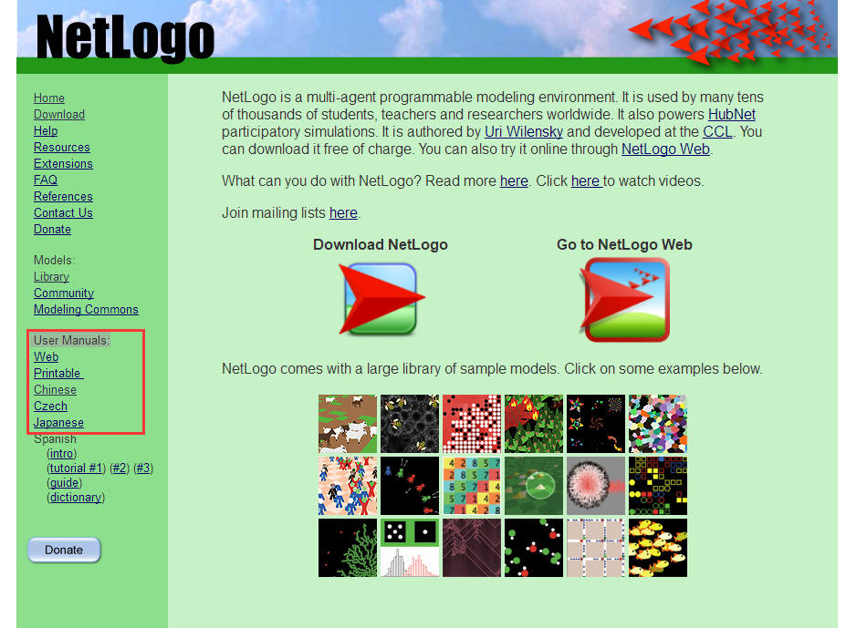
- How to install the software?
3.1、you should find this package from website or QQ group:
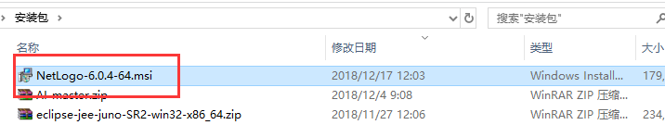
3.2、Double click Open -->Next
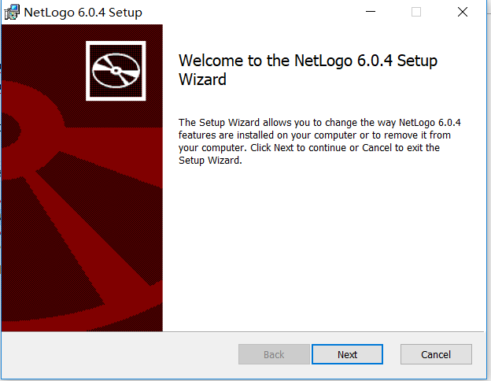
3.3、you can change the install address --> Next
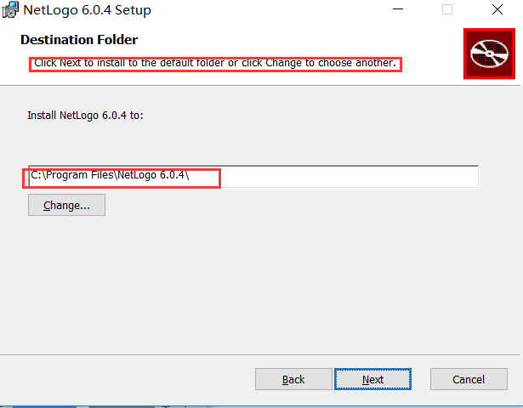
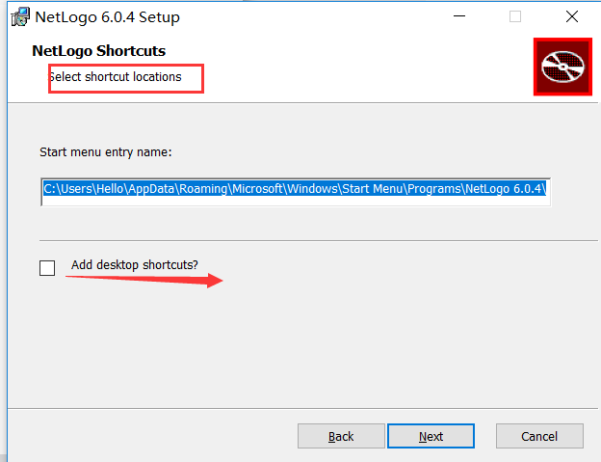
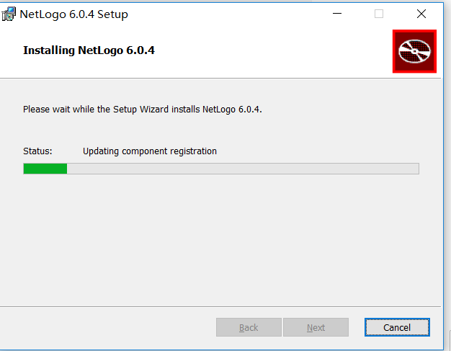
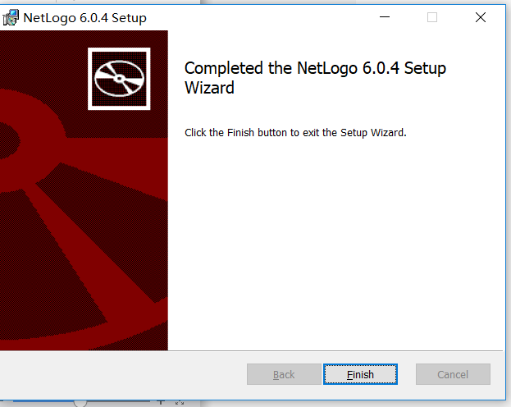
3.4、click Finish
3.5、How should we start the software?
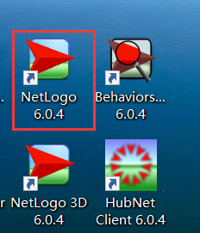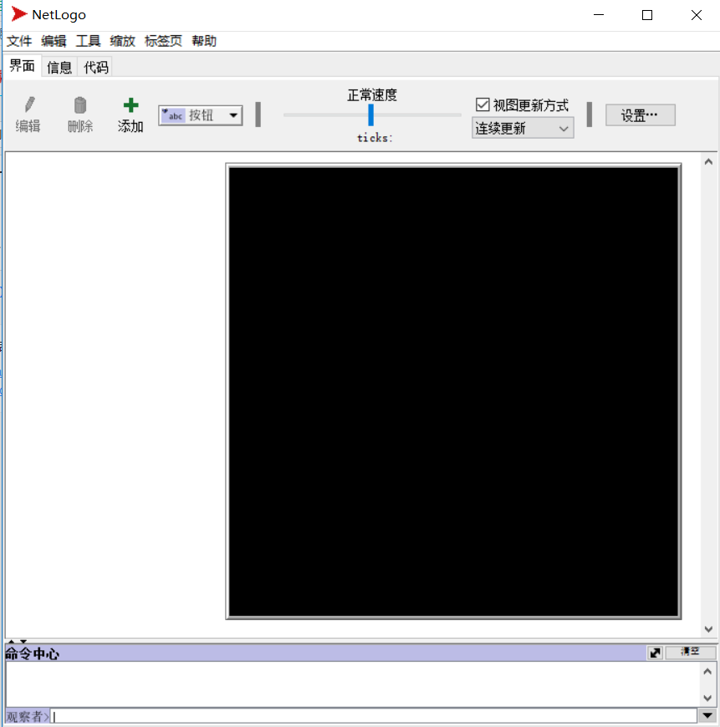
3.6、How to view the models library? For example. wolf sheep predation
3.6.1、 file-->model base,(Ctrl+m)
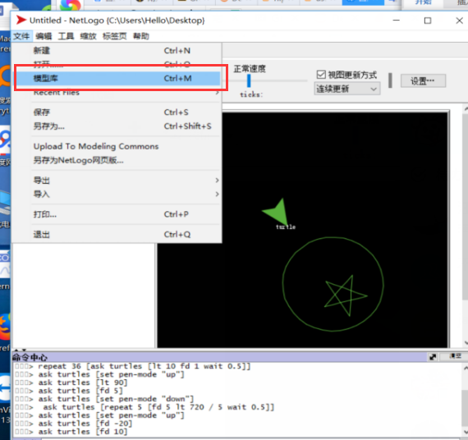
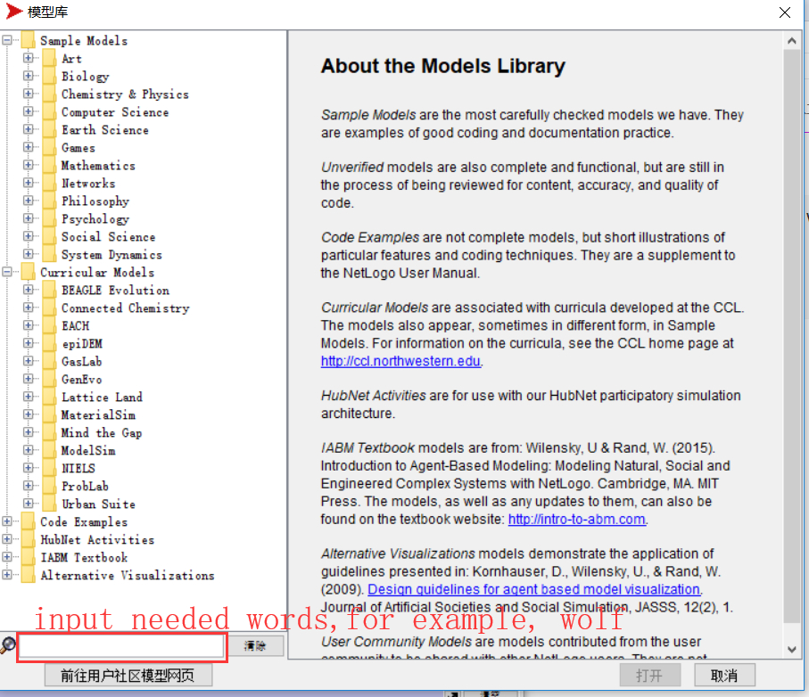

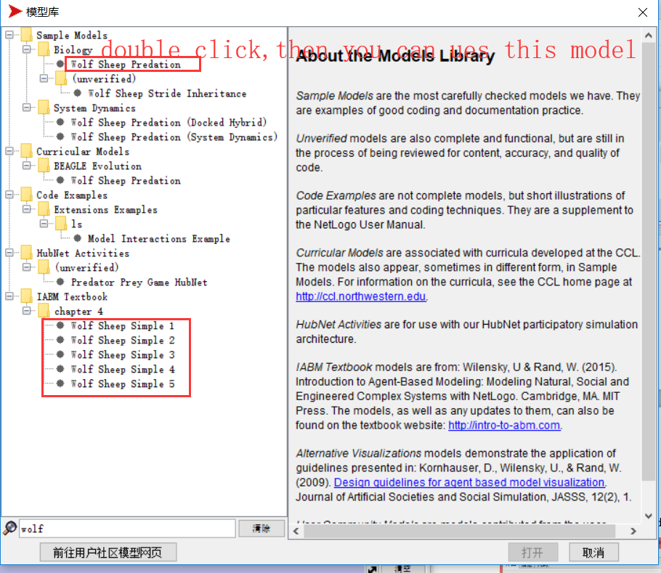
4、Now try to use Netlogo to draw a circle with a Pentagon inside.
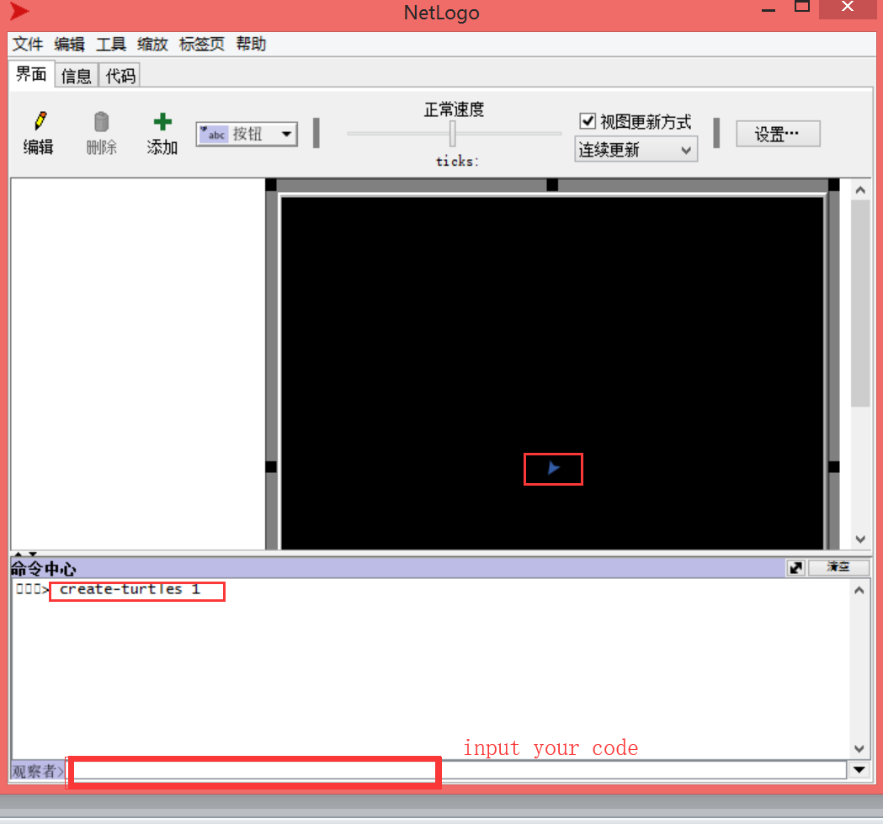
4.1、Code:
create-turtles 1 ;创建一直海龟
ask turtle 0 [set size 4 set color green] ;默认turtle是0，现在设置大小和颜色
ask turtle 0 [set label "turtle"] ;给turtle设置名字
ask turtles [set pen-mode "down"] ;让turtle运动后出现运动轨迹
repeat 36 [ask turtles [lt 10 fd 1 wait 0.5]] ;让turtle画圆
ask turtles [set pen-mode "up"] ;关闭turtle运动轨迹
ask turtles [lt 90] ;左转90度
ask turtles [fd 5] ;前进10
ask turtles [set pen-mode "down"]
ask turtles [repeat 5 [fd 5 lt 720 / 5 wait 0.5]] ;画五角星
ask turtles [set pen-mode "up"]
ask turtles [fd -20] ;后退20
ask turtles [fd 10]
4.2、result：
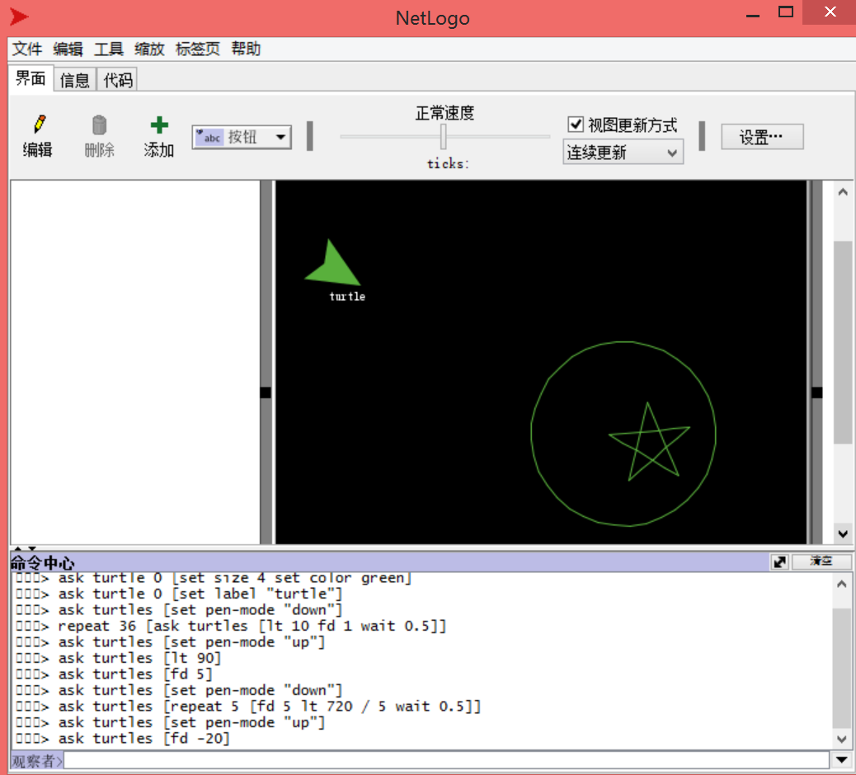
4.3、How to store the code？
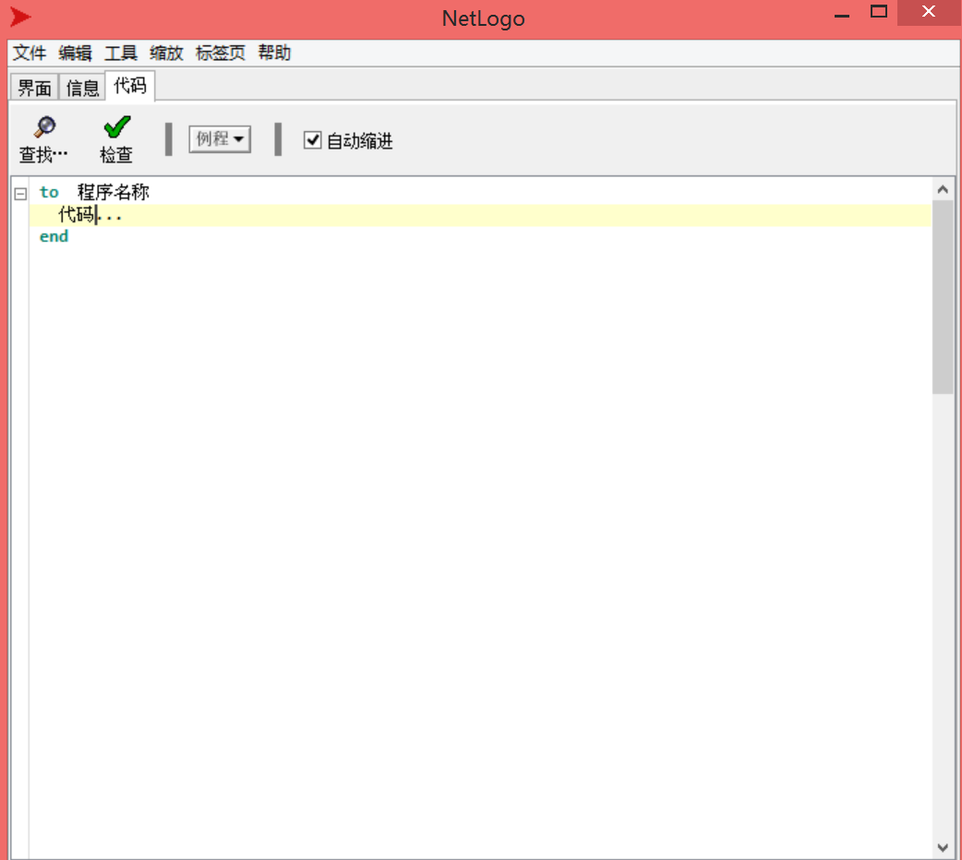
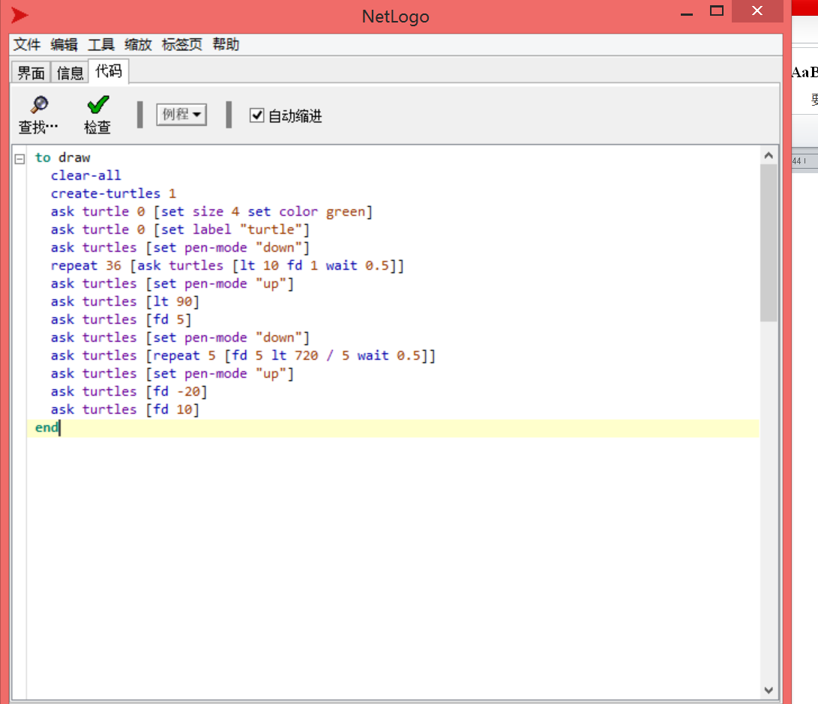
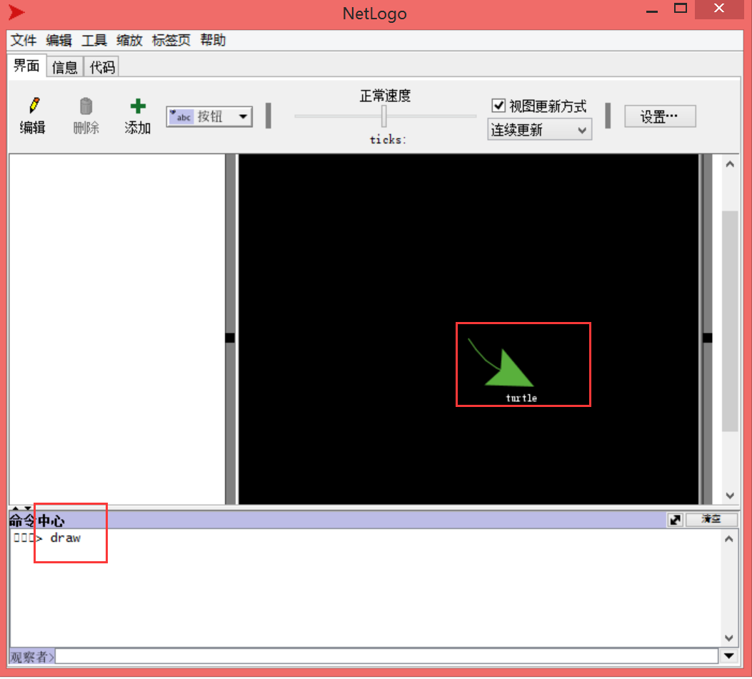

4.4、We can create a button to run the command.
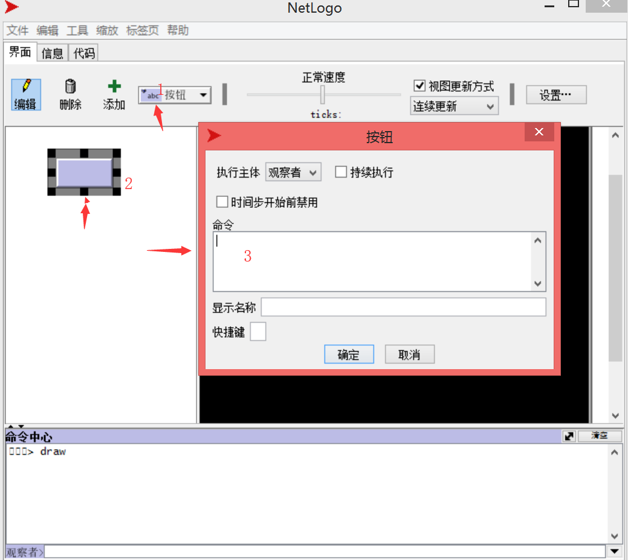

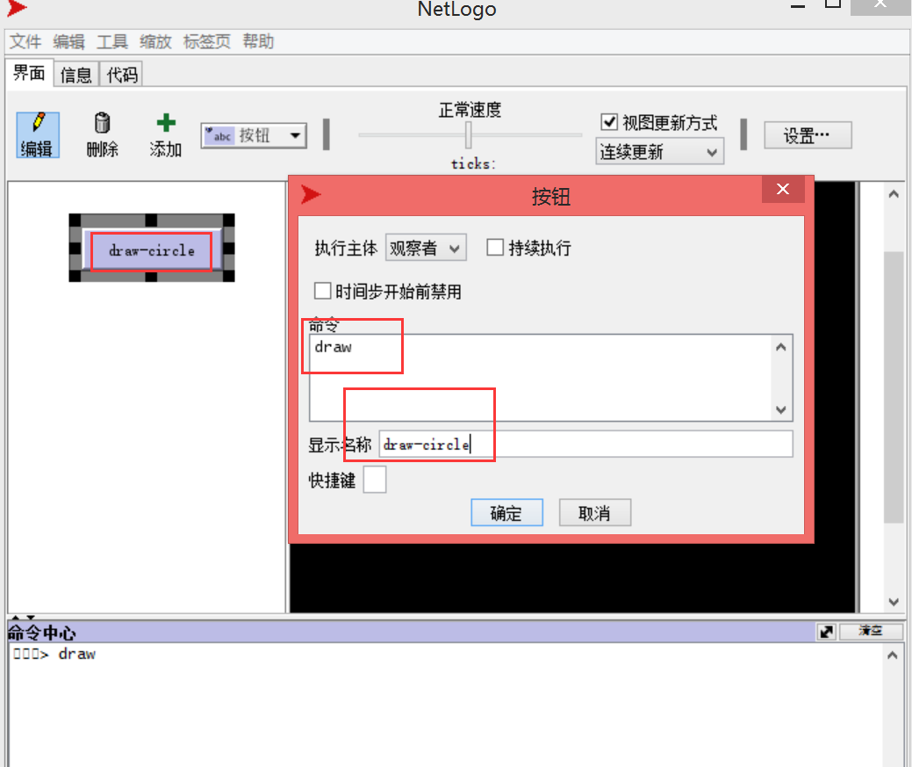
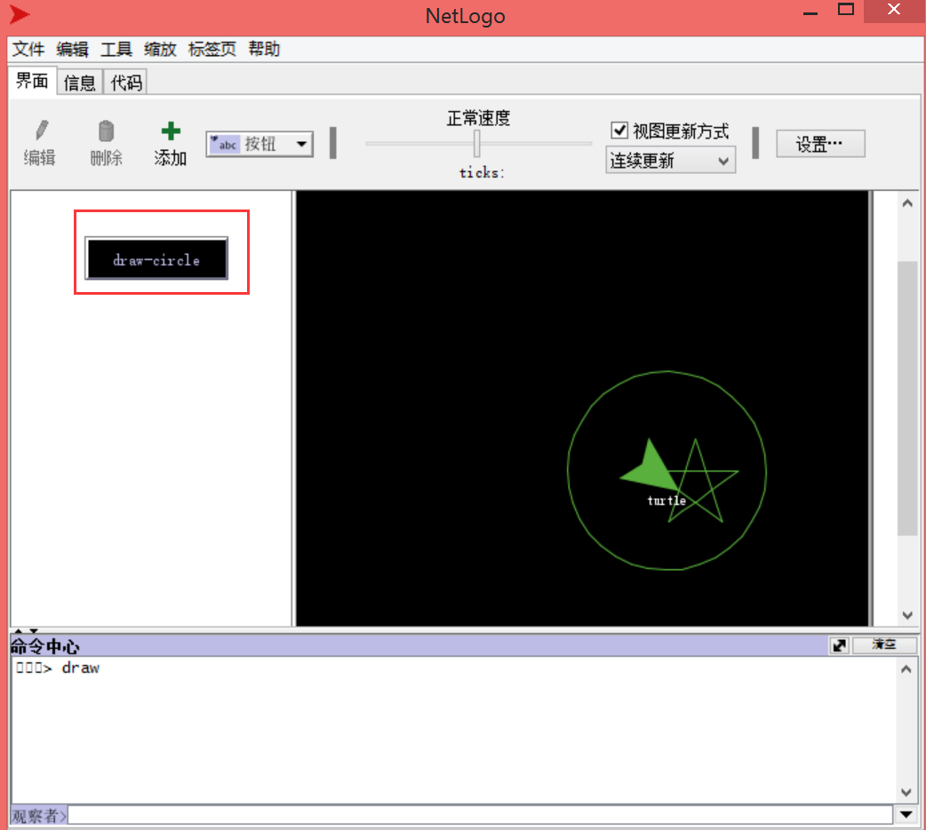

5、wolf sheep predation
5.1、Producing grass, sheep walking randomly.
Note: (“;” means code comment symbols)
Code:
breed [sheep a-sheep] ;定义一个物种
to setup
clear-all ;清除原来模型
ask patches [set pcolor green] ;设置草为绿色
create-sheep 100 ;创建100只羊
ask sheep [setxy random-xcor random-ycor] ;模拟羊随机产生位置
ask sheep [set shape "sheep"] ;设置羊的形状
ask sheep [set color white] ;设置羊的颜色
end

to go
ask sheep [fd 1 lt random 180 rt random 180] ;每次前进一步 随机转向
end
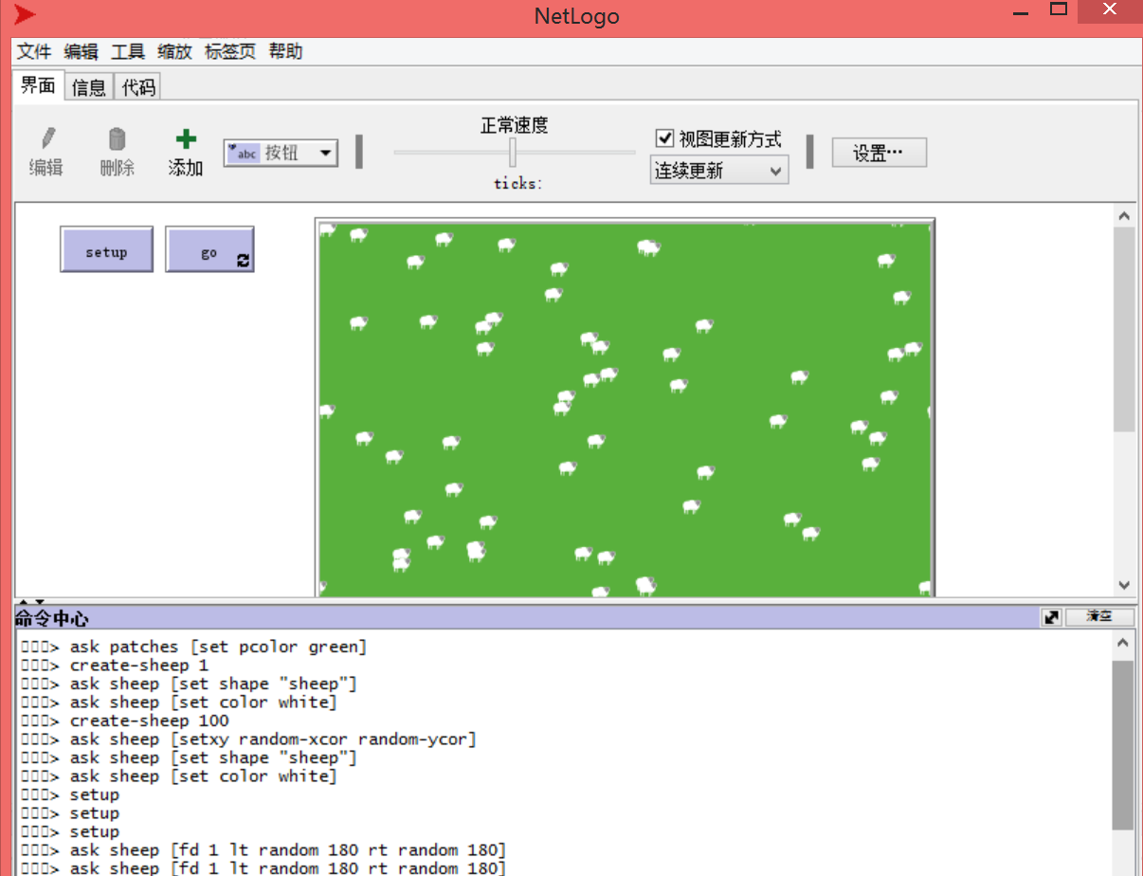
5.2、Set the energy of the sheep.
Code:
breed [sheep a-sheep] ;定义一个物种

sheep-own [energy]

to setup
clear-all
ask patches [ ;定义一个草原
set pcolor green
]
create-sheep 100 [
setxy random-xcor random-ycor ;使得绵羊随机分布
set shape "sheep"
set color white
set energy random 100 ;设置绵阳的能力随机
]

reset-ticks
end

to go
ask sheep [
wiggle
move
]

check-if-dead

tick
end

to wiggle
lt random 90
rt random 90
end

to move
fd 1
set energy energy - 1
if show-energy = true
[set label energy]
end

to check-if-dead
ask sheep [if energy < 0 [die]]
end
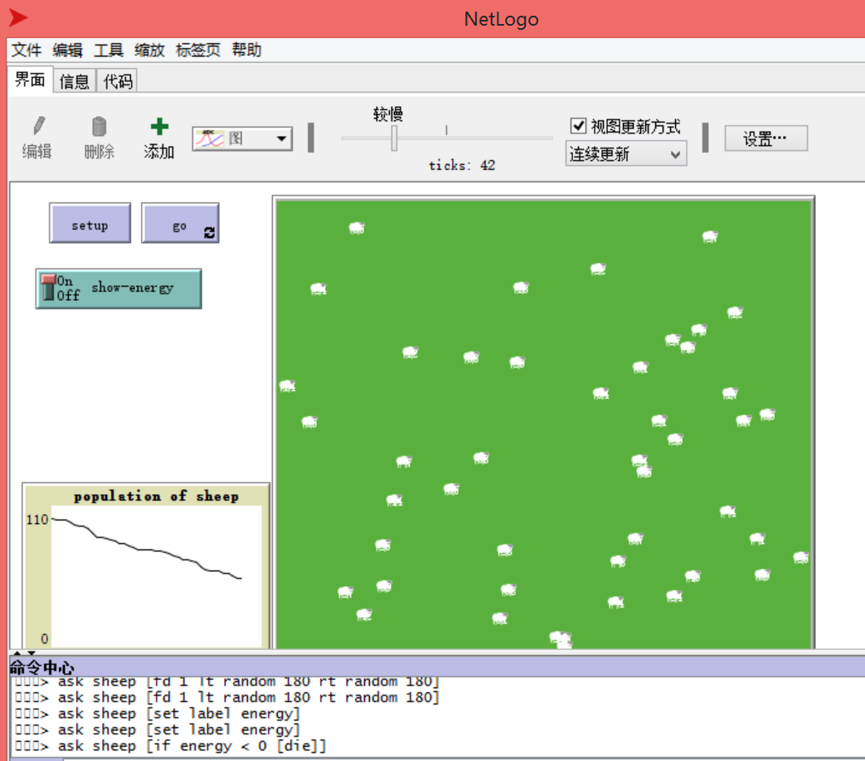

5.3、The sheep eats grass, the grass grows again.
Code:

to regrow-grass
ask patches[ ;设置草的能量不同
set grass grass + grass-regrowth-rate
if grass > 10 [set grass 10]
set pcolor scale-color green grass 0 30
]
end

to eat
if grass > 1 ;设置草被吃的时候能力大于1
[
set energy energy + energy-gain-from-grass
set grass grass - energy-gain-from-grass
]
End
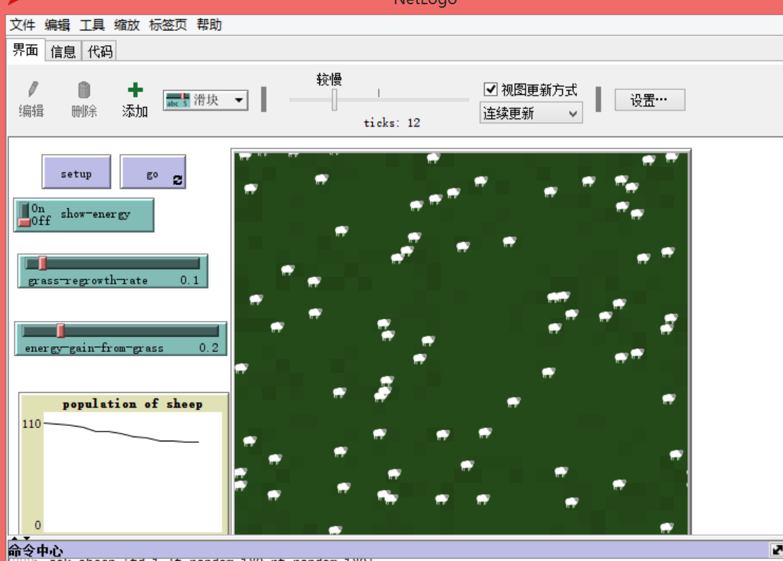

5.4、Sheep breeding
Code:

to reproduce ;生小羊
if energy > 200
[
hatch 1
[
set energy 100
]
set energy energy - 100
]
end

to updata-sheep
set size energy / 100.0
end

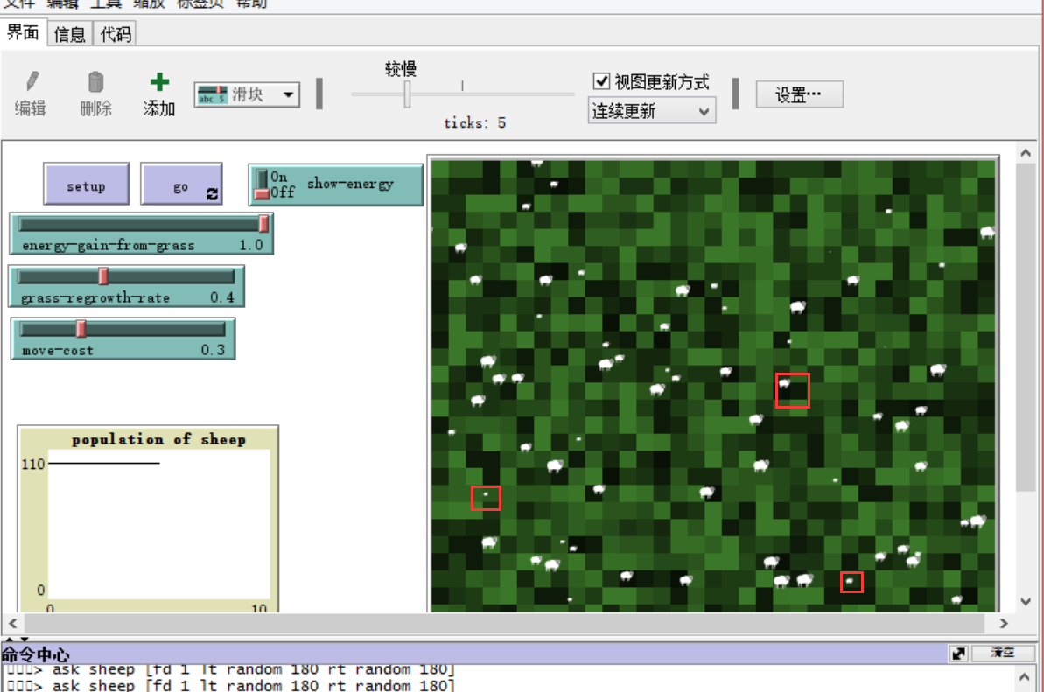
5.5 、create wolves, Wolf eating sheep, Wolf breeding
Code:
if any? sheep-here ;如果狼遇见羊，狼就吃掉羊，狼的能力增加
[
let target one-of sheep-here
ask target [die]
set energy energy + energy-gain-from-sheep
]
to go
ask turtles [
updata-size
wiggle
move
eat
reproduce
]
